**Problem Statement:-**

A leading gaming company based in San Mateo, California has been facing a lot of loss in revenue. They want to assess different aspects of their business and study the revenue contribution by each of them.

**Data Dictionary:-**

|  |  |  |  |
| --- | --- | --- | --- |
| **Table Name :- EngagementData** | | | |
| **Field Name** | **Data Type** | **Field Size** | **Description** |
| **Acct_ID** | Integer | 3 | Unique ID for user |
| **Date** | Date/Time | 10 | Date |
| **Total Playtime** | Integer | 3 | Total time of playing game |
| **Online Playtime** | Float | 4 | Time for playing game online |
| **Spends ($)** | Integer | 2 | Revenue |
| **Playtime Genre** | Text | 16 | Genre of game and app |
| **Spend Category** | Text | 4 | Games, DLC(Download game content), App |
| **Digital Purchase** | Text | 2 | Purchase game digitally or not |
| **Physical Purchase** | Text | 2 | Purchase game physically or not |

|  |  |  |  |
| --- | --- | --- | --- |
| **Table Name:- AcquistionCost** | | | |
| **Field Name** | **Data Type** | **Field Size** | **Description** |
| **Acct_id** | Integer | 3 | Unique ID for user |
| **Mode of Communication** | Text | 7 | Mode where client communicate with user |
| **#Times_communicated** | Integer | 1 | Number of communication happen |
| **Month** | Integer | 2 | Month of communication |

|  |  |  |  |
| --- | --- | --- | --- |
| **Table Name:- PerCommunicationModeCost** | | | |
| **Field Name** | **Data Type** | **Field Size** | **Description** |
| **Mode of Communication** | Text | 7 | Mode where client communicate with user |
| **Cost(in Cents)** | Integer | 2 | Per mode communication cost |

**ER Diagram:-**

Per Communication mode Cost

Generating Revenue and Cost on account id

PerCommunicationMode

AcquistionCost

EngagementData

**Date Cleaning:-**

* **Change the datatype of Date column from Datetime to date**

ALTER TABLE EngagementData ALTER COLUMN Date date not null;

* **Updating the average value with in [Spends ($)] column where outlier found.**

update EngagementData

set [Spends ($)] = (

select cast(avg([Spends ($)]) as numeric(36,2))

from engagementdata

where [Spends ($)] <> '1000000000')

where [Spends ($)] = '1000000000';

* **Now updating the average value with in [Total Playtime] column where outlier found.**

update engagementdata

set [Total Playtime] = (select cast(avg([Total Playtime]) as numeric(36,2))

from engagementdata

where [Total Playtime] not in ('-99', '99999999'))

where [Total Playtime] in ('-99', '99999999');

* **Updating [Online Playtime] with [Total Playtime] where [Online Playtime]>[Total Playtime]**

update engagementdata

set [Online Playtime]=[Total Playtime]

where [Online Playtime]>[Total Playtime];

* **Updating [Online Playtime] with Mean value where [Online Playtime] = '-99'**

update engagementdata

set [Online Playtime] = (

select cast(round(AVG([Online Playtime]),2) as numeric(36,2))

from engagementdata

where [Online Playtime]<>'-99')

where [Online Playtime]='-99'

* **Updating date column where outlier found**

update engagementdata

set date = '2019-01-01'

where date = '1900-01-01'

* **Updating month column with 201901 where value is 190001**

update aquisitioncost

set month = '201901'

where month = '190001'

* **Updating Mode value as it is categorical column where [Mode of Communication] is Blank**

update aquisitioncost

set [Mode of Communication] = (

select [Mode of Communication]

from(

select [Mode of Communication], count(*) total_count, DENSE_RANK() over (order by count(*) desc) rnk

from aquisitioncost

group by [Mode of Communication]) a

where a.rnk = 1)

where [Mode of Communication] = ' ';

* **Updating column Mode of Communication in AquisitionCost table.**

update aquisitioncost

set [Mode of Communication] = 'Mail'

where [Mode of Communication] = 'MaiL'

update aquisitioncost

set [Mode of Communication] = 'WeChat'

where [Mode of Communication] = 'WeChAt'

* **Updating column Mode of Communication in PerCommunicationCost table.**

update percommunicationmodecost

set [Mode of Communication] = 'Mail'

where [Mode of Communication] = 'Mail'

update percommunicationmodecost

set [Mode of Communication] = 'YouTube'

where [Mode of Communication] = 'YOuTube';

update percommunicationmodecost

set [Mode of Communication] = 'WeChat'

where [Mode of Communication] = 'WEChat';

* **Update column month from table AquisitionCost**

update AquisitionCost

set Month = RIGHT(Month,2);

**EDA Analysis:-**

1. **Univariate Analysis:-**
   1. Playtime Genre Analysis.

select [Playtime Genre], count(*) Total_count

from EngagementData

group by [Playtime Genre]

order by count(*) desc;

**Output:-**

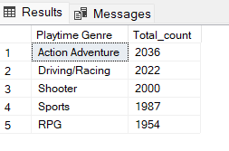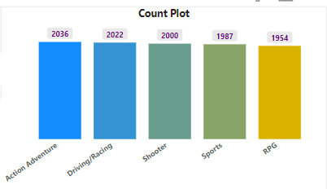

Output is clearly showing that most of the players are playing Action Adventure game and very less players are playing RPG.

* 1. Spend Category Analysis.

select [Spend Category], count(*) Total_count

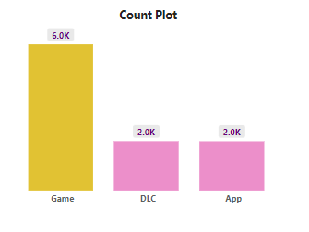from EngagementData

group by [Spend Category]

order by count(*) desc;

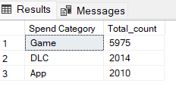**Output:-**

Output is clearly showing that most of the players are playing games only.

* 1. Purchase Category Analysis.

select *

from (select Case when [Digital Purchase] = 'NA' then 'Not Purchasing'

when [Digital Purchase] = '1' Then 'Digitally Purchase'

when [Digital Purchase] = '0' then 'Physically Purchase'

end Purchase, count(*) Total_Count

from EngagementData

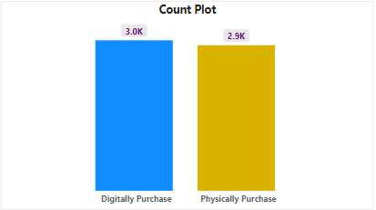group by [Digital Purchase])a

where a.Purchase <> 'Not Purchasing'

order by a.Total_Count desc;

Output:-

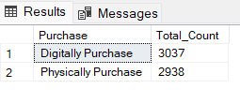

Output is clearly showing that most of the players are purchasing game digitally.

* 1. Revenue Analysis

select Max([Spends ($)]) [Maximum Revenue ($)], Min([Spends ($)]) [Minimum Revenue ($)], AVG([Spends ($)]) [Mean Revenue ($)]

from EngagementData;

**Output:-**



* 1. Total Playtime Analysis

select Max([Total Playtime]) [Maximum Time (hr)], Min([Total Playtime]) [Minimum Time (hr)], AVG([Total Playtime]) [Mean Time (hr)]

from EngagementData;

**Output:-**



* 1. Online Playtime Analysis

select Max([Online Playtime]) [Maximum Time (hr)], Min([Online Playtime]) [Minimum Time (hr)], AVG([Online Playtime]) [Mean Time (hr)]

from EngagementData;

**Output:-**



1. **Bivariate Analysis:-**
   1. Monthly revenue trends.

select month(date) Month, Sum([Spends ($)]) [Total Revenue ($)]

from EngagementData

group by month(date)

order by month(date);

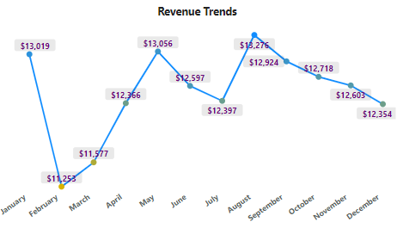**Output:-**

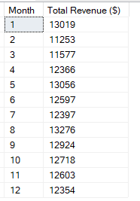

﻿At 13276, August had the highest Total Revenue and was 17.98% higher than February, which had the lowest Total Revenue at 11253. Revenue generated by August is 8.84%.

* 1. Monthly revenue trends where players are not purchasing any game.

select month(date) Month, Sum([Spends ($)]) [Total Revenue ($)]

from EngagementData

where [Digital Purchase] = 'NA' and [Physical Purchase] = 'NA'

group by year(date), month(date)

order by year(date), month(date);

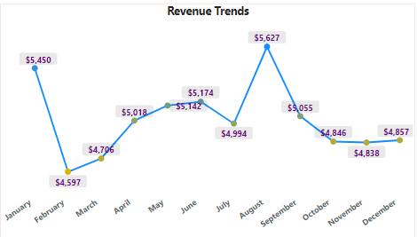**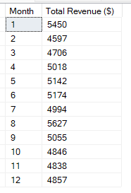Output:-**

In the month of August, revenue generation was the highest, which was 9.33% and was 22.6% higher than February month. Which had the lowest revenue 4597 (7.62%).

* 1. Monthly revenue trends where players are purchasing any game.

select month(date) Month, Sum([Spends ($)]) [Total Revenue ($)]

from EngagementData

where [Digital Purchase] = '1' or [Physical Purchase] = '1'

group by year(date), month(date)

order by year(date), month(date);

**Output:-**

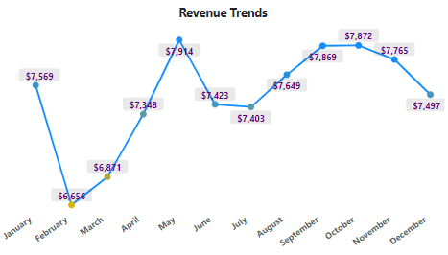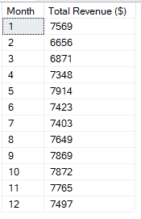

Output is clearly showing that in the month of May revenue generation was the highest, which was 8.8% and was 18.9% higher than February month, which had the lowest revenue 4597 (7.4%).

* 1. Monthly Total playtime trends.

select Month(date) Month, SUM([Total Playtime]) [Total Playtime (hr)]

from EngagementData

group by Month(date)

order by Month(date);

**Output:-**

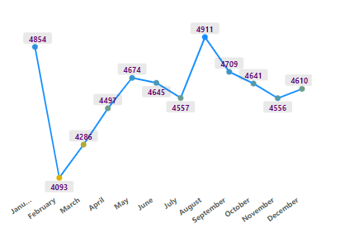

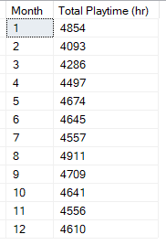

It has clearly shown that in the month of August, players spent most of their time playing games that was 8.92% and was 19.9% higher than February, which had the lowest value 7.44%.

* 1. Monthly Online and Offline playtime trends.

select Month(date) Month, Cast(SUM([Online Playtime]) as numeric(36,2)) [Total Online Playtime (hr)],

cast(Sum([Total Playtime] - [Online Playtime]) as numeric(36,2))

[Total Offline Playtime (hr)]

from EngagementData

group by Month(date)

order by Month(date);

**Output:-**

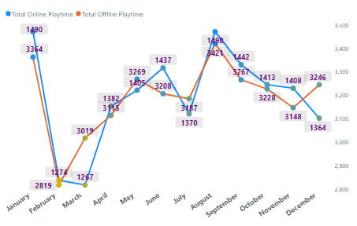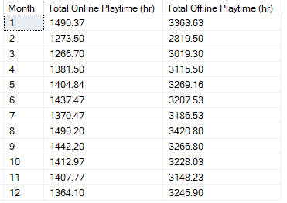

It has clearly shown that in the month of January & August players spent most of the time playing games online and in August, they spent most of the time playing games offline. The trends clearly told that players are spending most of the time in offline.

* 1. Monthly Time trends where players are not purchasing any game.

select month(date) Month, Sum([Total Playtime]) [Total Playtime (hr)]

from EngagementData

where [Digital Purchase] = 'NA' and [Physical Purchase] = 'NA'

group by month(date)

order by month(date);

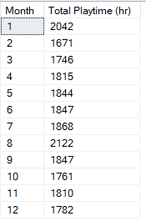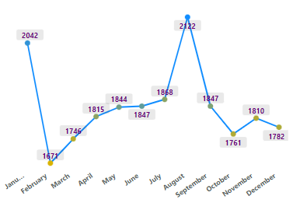**Output:-**

It has clearly shown that in the month of August players spent most of the time playing games.

* 1. Monthly Time trends where players are purchasing any game.

select month(date) Month, Sum([Total Playtime]) [Total Playtime (hr)]

from EngagementData

where [Digital Purchase] = '1' or [Physical Purchase] = '1'

group by month(date)

order by month(date);

**Output:-**

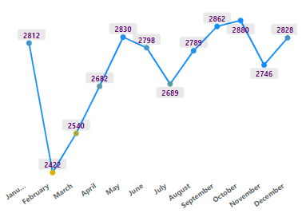

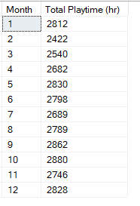

* 1. Monthly Online & Offline Time trends where players are not purchasing any game.

select Month(date) Month, Cast(SUM([Online Playtime]) as numeric(36,2)) [Total Online Playtime (hr)],

cast(Sum([Total Playtime] - [Online Playtime]) as numeric(36,2)) [Total Offline Playtime (hr)]

from EngagementData

where [Digital Purchase] = 'NA' and [Physical Purchase] = 'NA'

group by month(date)

order by month(date);

**Output:-**

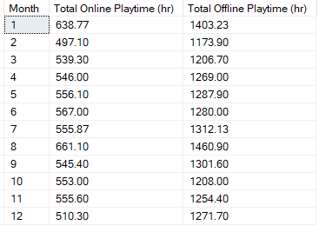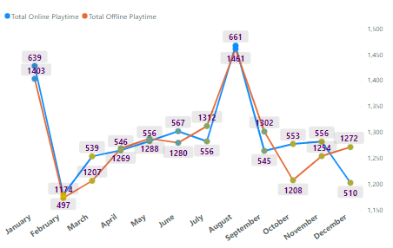

It has clearly shown that in the month of August players spent most of the time playing games online and offline. The trends clearly told that players are spending most of the time in offline.

* 1. Monthly Online & Offline Time trends where players are purchasing game.

select Month(date) Month, Cast(SUM([Online Playtime]) as numeric(36,2)) [Total Online Playtime (hr)],

cast(Sum([Total Playtime] - [Online Playtime]) as numeric(36,2)) [Total Offline Playtime (hr)]

from EngagementData

where [Digital Purchase] = '1' or [Physical Purchase] = '1'

group by month(date)

order by month(date);

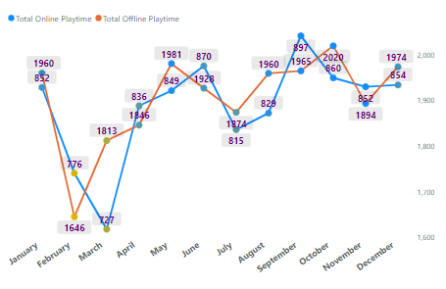**Output:-**

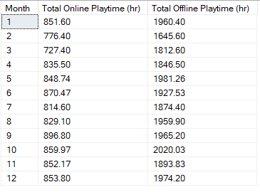

It has clearly shown that in the month of September players spent most of the time playing games online and in October, they spent most of the time playing games offline. The trends clearly told that players are spending most of the time in offline.

* 1. Total Time based on Genre.

select [Playtime Genre], SUM([Total Playtime]) [Total Playtime (hr)]

from EngagementData

group by [Playtime Genre]

order by sum([Total Playtime]) desc;

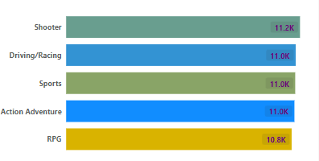**Output:-**

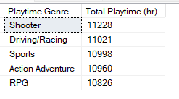

It has clearly shown that players are playing Shooter game maximum time and RPG minimum time.

* 1. Online & Offline playtime based on Genre.

select [Playtime Genre], Cast(SUM([Online Playtime]) as numeric(36,2)) [Total Online Playtime (hr)],

cast(Sum([Total Playtime] - [Online Playtime]) as numeric(36,2)) [Total Offline Playtime (hr)]

from EngagementData

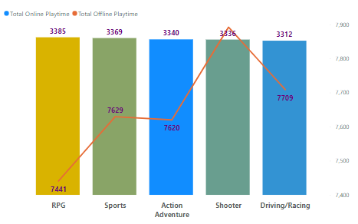group by [Playtime Genre]

order by [Playtime Genre];

**Output:-**

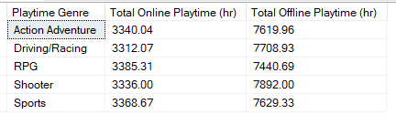

It has clearly shown that players are playing maximum time RPG game Online and Shooter game Offline.

* 1. Revenue generation based on Genre.

select [Playtime Genre], SUM([Spends ($)]) [Total Revenue ($)]

from EngagementData

group by [Playtime Genre]

order by SUM([Spends ($)]) desc;

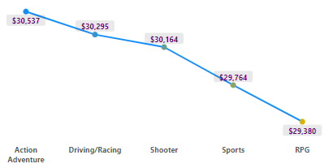**Output:-**

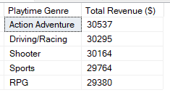

It has clearly shown that players are spending most of the amount on Action Adventure and very less amount in RPG. The difference in revenue generation is very less between all of the genres.

* 1. Revenue generation based on Genre where users are not purchasing any game.

select [Playtime Genre], SUM([Spends ($)]) [Total Revenue ($)]

from EngagementData

where [Digital Purchase] = 'NA' and [Physical Purchase] = 'NA'

group by [Playtime Genre]

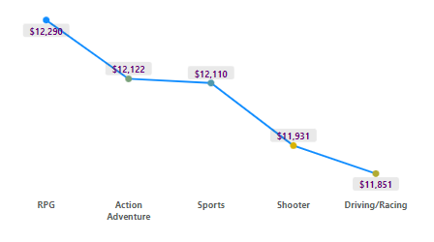order by SUM([Spends ($)]) desc;

**Output:-**

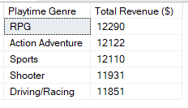

It has clearly shown that players are spending most of the amount on RPG. The difference in revenue generation is very less between all of the genres.

* 1. Revenue generation based on Genre where users are purchasing any game.

select [Playtime Genre], SUM([Spends ($)]) [Total Revenue ($)]

from EngagementData

where [Digital Purchase] = '1' or [Physical Purchase] = '1'

group by [Playtime Genre]

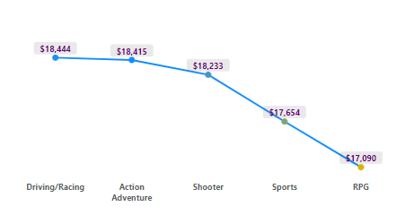order by SUM([Spends ($)]) desc;

**Output:-**

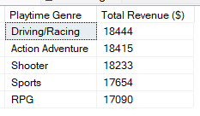

It has clearly shown that players are spending most of the amount on Driving/Racing. The difference in revenue generation is very less between all of the genres.

* 1. Revenue generation based on Spend Category.

select [Spend Category], SUM([Spends ($)]) [Total Revenue ($)]

from EngagementData

group by [Spend Category]

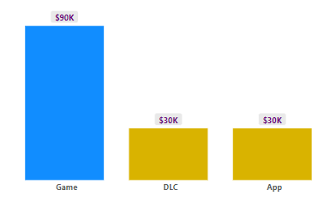order by SUM([Spends ($)]) desc;

**Output:-**

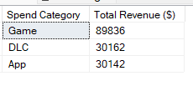

It has clearly shown that players are spending most of the amount on Game.

* 1. Total number of communication based on Communication Mode.

select [Mode of Communication] as [Mode of Communication], Sum(#Times_communicated) Total_Count_of_communication

from aquisitioncost

group by [Mode of Communication];

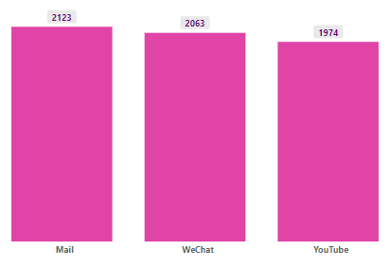**Output:-**

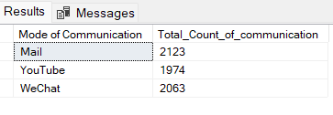

It is clearly showing that most of the time company has communicated with users by Mail.

* 1. Total expenditure of company based on Communication Mode.

select a.[Mode of Communication], Sum(#Times_communicated*[Cost (in Cents)]) [Total Cost ($)]

from aquisitioncost a

join PerCommunicationModeCost p

on a.[Mode of Communication] = p.[Mode of Communication]

group by a.[Mode of Communication]

order by Sum(#Times_communicated*[Cost (in Cents)]) desc;

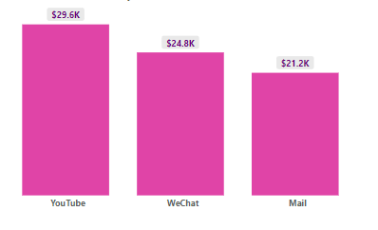**Output:-**

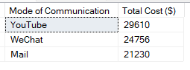

It is clearly showing that the company has spent the maximum money to communicate with users through YouTube.

1. **New Table Creation:-**
   1. **Month wise Profit table creation:-**

with cte1 as(

select Month, Sum(#Times_communicated*[Cost (in Cents)]) [Cost ($)]

from AquisitionCost a

join PerCommunicationModeCost p

on a.[Mode of Communication] = p.[Mode of Communication]

group by Month),

cte2 as(

select Month(Date) Month, Sum([Spends ($)]) [Revenue ($)]

from engagementdata

group by Month(Date))

select c1.Month, Revenue, Cost, (Revenue-Cost) [Profit ($)]

from cte1 c1

join cte2 c2

on c1.Month = c2.Month

order by c1.Month;

**Output:-**

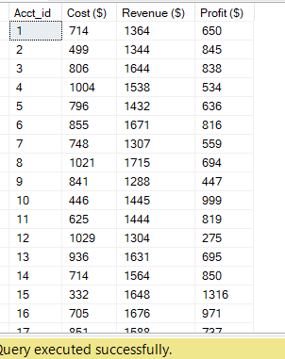

* **Top 10 Customer based on Playtime.**

with cte1 as(

select Acct_ID, SUM([Total Playtime]) [Total Playtime (hr)], rank() over(order by SUM([Total Playtime]) desc) rnk

from EngagementData

group by Acct_ID)

select Acct_ID, [Total Playtime (hr)]

from cte1

where rnk between 1 and 10;

**Output:-**

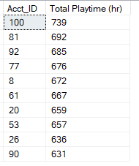

* **Top 10 Customer based on Online Playtime.**

with cte1 as(

select Acct_ID, Cast(SUM([Online Playtime]) as numeric(36,2)) [Total Online Playtime (hr)], rank() over(order by SUM([Online Playtime]) desc) rnk

from EngagementData

group by Acct_ID)

select Acct_ID, [Total Online Playtime (hr)]

from cte1

where rnk between 1 and 10;

**Output:-**

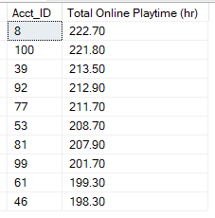

* **Top 10 Customer based on Offline Playtime.**

with cte1 as(

select Acct_ID, Cast(SUM([Total Playtime]-[Online Playtime]) as numeric(36,2)) [Total Offline Playtime (hr)], rank() over(order by SUM([Total Playtime]-[Online Playtime]) desc) rnk

from EngagementData

group by Acct_ID)

select Acct_ID, [Total Offline Playtime (hr)]

from cte1

where rnk between 1 and 10;

**Output:-**

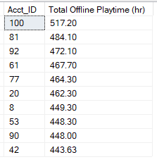

* **Top 10 Customer based on Revenue.**

with cte1 as(

select Acct_ID, SUM([Spends ($)]) [Total Revenue ($)], rank() over(order by SUM([Spends ($)]) desc) rnk

from EngagementData

group by Acct_ID)

select Acct_ID, [Total Revenue ($)]

from cte1

where rnk between 1 and 10;

**Output:-**

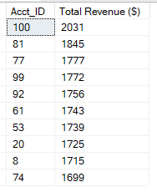

* **Top 10 Dates based on Revenue.**

with cte1 as(

select date, SUM([Spends ($)]) Total_Revenue, rank() over(order by SUM([Spends ($)]) desc) rnk

from EngagementData

group by date)

select date, Total_Revenue

from cte1

where rnk between 1 and 10;

**Output:-**

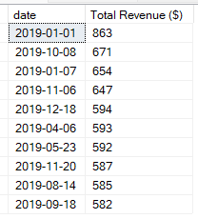

* **Top 10 customer where company spending money more.**

with cte1 as(

select acct_id, [Mode of Communication],Sum(#Times_communicated) Total_Communication

from AquisitionCost

group by acct_id,[Mode of Communication]),

cte2 as (

select Acct_id, Sum(Total_Communication*[Cost (in Cents)]) [Cost ($)]

from cte1 c

join PerCommunicationModeCost p

on c.[Mode of Communication] = p.[Mode of Communication]

group by Acct_id),

cte3 as(

select Acct_ID, sum([Spends ($)]) [Revenue ($)]

from EngagementData

group by Acct_ID),

cte4 as(

select c1.Acct_id, [Cost ($)], [Revenue ($)], ([Revenue ($)]-[Cost ($)]) [Profit ($)], rank() over(order by [Cost ($)] desc) rnk

from cte2 c1

join cte3 c3

on c1.acct_id = c3.acct_id)

select Acct_id, [Cost ($)]

from cte4

where rnk between 1 and 10

**Output:-**

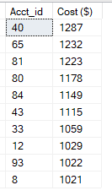

* **Top 10 customer based on Profit.**

with cte1 as(

select acct_id, [Mode of Communication],Sum(#Times_communicated) Total_Communication

from AquisitionCost

group by acct_id,[Mode of Communication]),

cte2 as (

select Acct_id, Sum(Total_Communication*[Cost (in Cents)]) [Cost ($)]

from cte1 c

join PerCommunicationModeCost p

on c.[Mode of Communication] = p.[Mode of Communication]

group by Acct_id),

cte3 as(

select Acct_ID, sum([Spends ($)]) [Revenue ($)]

from EngagementData

group by Acct_ID),

cte4 as(

select c1.Acct_id, [Cost ($)], [Revenue ($)], ([Revenue ($)]-[Cost ($)]) [Profit ($)], rank() over(order by ([Revenue ($)]-[Cost ($)]) desc) rnk

from cte2 c1

join cte3 c3

on c1.acct_id = c3.acct_id)

select Acct_id, [Profit ($)]

from cte4

where rnk between 1 and 10;

**Output:-**

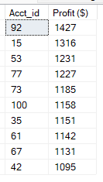

**Findings:**

**Part 1**

1. What is the favourite genre in terms of playtime?

**Ans:-**

with cte1 as(

select [Playtime Genre], SUM([Total Playtime]) [Total Playtime (hr)], rank() over(order by SUM([Total Playtime]) desc) rnk

from EngagementData

group by [Playtime Genre])

select [Playtime Genre], [Total Playtime (hr)]

from cte1

where rnk = 1;

**Output:-**



1. What is the genre on which the users spend most?

**Ans:-**

with cte1 as(

select [Playtime Genre], SUM([Spends ($)]) [Total Revenue ($)], rank() over(order by SUM([Spends ($)]) desc) rnk

from EngagementData

group by [Playtime Genre]

)

select [Playtime Genre], [Total Revenue ($)]

from cte1

where rnk = 1;

**Output:-**



1. Is this changing over time?

**Ans:-** The below query is showing the date-wise genre where users spend the most and the output is clearly showing that it is changing over time.

with cte1 as(

select month(date) Month,[Playtime Genre], SUM([Spends ($)]) [Total Revenue ($)]

from EngagementData

group by month(date),[Playtime Genre]),

cte2 as(

select *, rank() over (Partition by Month order by [Total Revenue ($)] desc) rnk

from cte1)

select Month, [Playtime Genre],[Total Revenue ($)]

from cte2

where rnk = 1;

**Output:-**

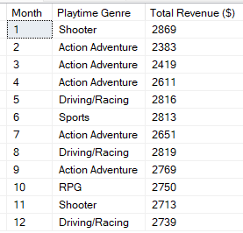

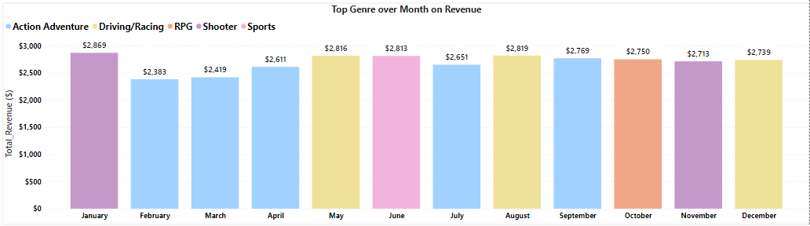

The below query is showing the genre where users spend the most of the time and the output is clearly showing that it is changing over time.

with cte1 as(

select month(date) Month,[Playtime Genre], SUM([Total Playtime]) [Total Playtime (hr)]

from EngagementData

group by month(date),[Playtime Genre]),

cte2 as(

select *, rank() over (Partition by Month order by [Total Playtime (hr)] desc) rnk

from cte1)

select Month, [Playtime Genre], [Total Playtime (hr)]

from cte2

where rnk = 1;

**Output:-**

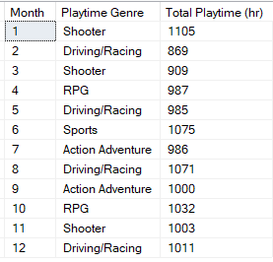

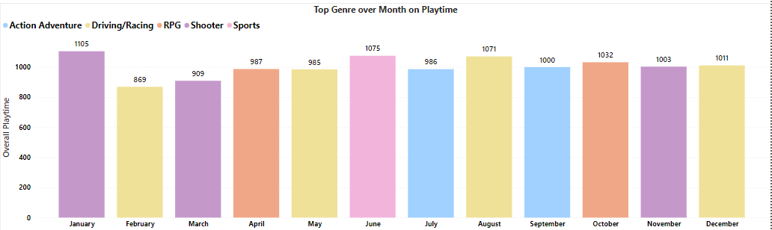

1. Do players buy games physically or digitally more?

***Ans:-***

With cte1 as(

select *

from (select Case when [Digital Purchase] = 'NA' then 'Not Purchasing'

when [Digital Purchase] = '1' Then 'Digitally Purchase'

when [Digital Purchase] = '0' then 'Physically Purchase'

end Purchase, count(*) Total_Count

from EngagementData

group by [Digital Purchase])a

where a.Purchase <> 'Not Purchasing'),

cte2 as(

select *, rank() over(order by Total_Count desc) rnk

from cte1)

select Purchase, Total_Count

from cte2

where rnk = 1;

**Output:-**



1. What is the spend distribution?

***Ans:-***

select *

from (select Case when [Digital Purchase] = 'NA' then 'Not Purchasing'

when [Digital Purchase] = '1' Then 'Digitally Purchase'

when [Digital Purchase] = '0' then 'Physically Purchase'

end Purchase, sum([Spends ($)]) [Total Revenue ($)]

from EngagementData

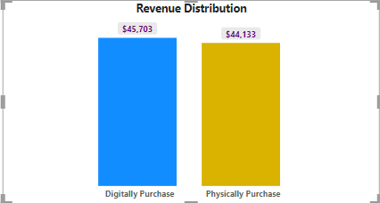group by [Digital Purchase])a

where a.Purchase <> 'Not Purchasing'

order by a.[Total Revenue ($)] desc;

**Output:-**

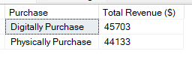

1. Is this changing over time?

***Ans:-*** The below query is showing the purchase category where users spend the most of the money and the output is clearly showing that it is changing over time.

with cte1 as(

select *

from (select month(date) Month, Case when [Digital Purchase] = 'NA' then 'Not Purchasing'

when [Digital Purchase] = '1' Then 'Digitally Purchase'

when [Digital Purchase] = '0' then 'Physically Purchase'

end Purchase, sum([Spends ($)]) [Total Revenue ($)]

from EngagementData

group by month(date),[Digital Purchase])a

where a.Purchase <> 'Not Purchasing'),

cte2 as(

select *, rank() over(Partition by Month order by [Total Revenue ($)] desc) rnk

from cte1)

select Month, purchase, [Total Revenue ($)]

from cte2

where rnk = 1;

**Output:-**

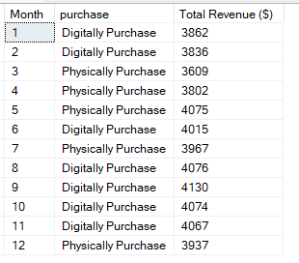

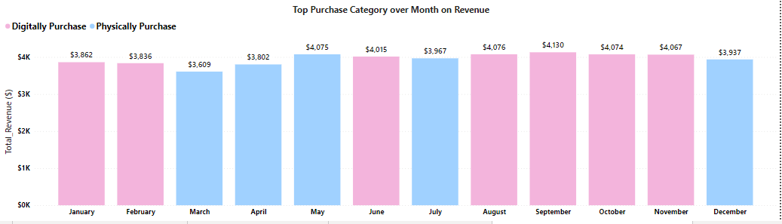

**Part 3: ROI Generation:-**

* What is the Overall ROI?

**Ans:-** ROI (Return On Investment) is calculated by dividing the profit earned on an investment by the cost of that investment.

**ROI** = (Revenue-Cost)/Cost*100

with cte1 as(

select acct_id, [Mode of Communication],Sum(#Times_communicated) Total_Communication

from AquisitionCost

group by acct_id,[Mode of Communication]),

cte2 as (

select Acct_id, Sum(Total_Communication*[Cost (in Cents)]) Cost

from cte1 c

join PerCommunicationModeCost p

on c.[Mode of Communication] = p.[Mode of Communication]

group by Acct_id),

cte3 as(

select Acct_ID, sum([Spends ($)]) Revenue

from EngagementData

group by Acct_ID),

cte4 as(

select c1.Acct_id, Cost, Revenue, (Revenue-Cost) Profit

from cte2 c1

join cte3 c3

on c1.acct_id = c3.acct_id),

cte5 as(

select SUm(Revenue) Total_Revenue, Sum(Cost) Total_Cost, Sum(Profit) Total_Profit

from cte4)

select cast(((Total_Revenue-Total_Cost)/Total_Cost)*100 as numeric(36,2)) ROI

from cte5;

**Output:-**

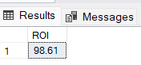

* **What is the distribution of accounts who have resulted in**
  + **Positive ROI**

**Ans:-**

with cte1 as(

select acct_id, [Mode of Communication],Sum(#Times_communicated) Total_Communication

from AquisitionCost

group by acct_id,[Mode of Communication]),

cte2 as (

select Acct_id, Sum(Total_Communication*[Cost (in Cents)]) Cost

from cte1 c

join PerCommunicationModeCost p

on c.[Mode of Communication] = p.[Mode of Communication]

group by Acct_id),

cte3 as(

select Acct_ID, sum([Spends ($)]) Revenue

from EngagementData

group by Acct_ID),

cte4 as(

select c1.Acct_id, Cost, Revenue, (Revenue-Cost) Profit

from cte2 c1

join cte3 c3

on c1.acct_id = c3.acct_id)

select Acct_id, (((Revenue-Cost)/Cost)*100) ROI

from cte4

where (((Revenue-Cost)/Cost)*100) >0

order by (((Revenue-Cost)/Cost)*100) desc;

**Output:-**

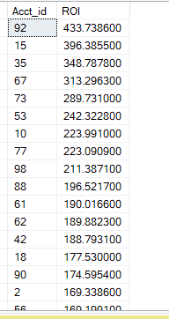

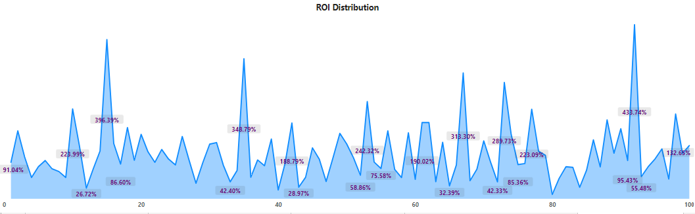

* + **Break-Even-Point**

**Ans:-**

with cte1 as(

select acct_id, [Mode of Communication],Sum(#Times_communicated) Total_Communication

from AquisitionCost

group by acct_id,[Mode of Communication]),

cte2 as (

select Acct_id, Sum(Total_Communication*[Cost (in Cents)]) Cost

from cte1 c

join PerCommunicationModeCost p

on c.[Mode of Communication] = p.[Mode of Communication]

group by Acct_id),

cte3 as(

select Acct_ID, sum([Spends ($)]) Revenue

from EngagementData

group by Acct_ID),

cte4 as(

select c1.Acct_id, Cost, Revenue, (Revenue-Cost) Profit

from cte2 c1

join cte3 c3

on c1.acct_id = c3.acct_id)

select Acct_id, (((Revenue-Cost)/Cost)*100) ROI

from cte4

where (((Revenue-Cost)/Cost)*100) = 0

order by Acct_id;

**Output:-**



* + **Negative ROI**

**Ans:-**

with cte1 as(

select acct_id, [Mode of Communication],Sum(#Times_communicated) Total_Communication

from AquisitionCost

group by acct_id,[Mode of Communication]),

cte2 as (

select Acct_id, Sum(Total_Communication*[Cost (in Cents)]) Cost

from cte1 c

join PerCommunicationModeCost p

on c.[Mode of Communication] = p.[Mode of Communication]

group by Acct_id),

cte3 as(

select Acct_ID, sum([Spends ($)]) Revenue

from EngagementData

group by Acct_ID),

cte4 as(

select c1.Acct_id, Cost, Revenue, (Revenue-Cost) Profit

from cte2 c1

join cte3 c3

on c1.acct_id = c3.acct_id)

select Acct_id, (((Revenue-Cost)/Cost)*100) ROI

from cte4

where (((Revenue-Cost)/Cost)*100) < 0

order by Acct_id;

**Output:-**



Above all three outputs are showing that all account from where players are playing games the ROI is positive. There are no such account where ROI is in Break-event-point or Negative.